
Accounting, Bookkeeping, Taxes, Payroll, W-2 and 1099 Reporting
2024 Year End Reminders for Businesses:
2024 is rapidly coming to a close, which means it is time to complete 2024 accounting and other tasks. Businesses are reminded that year-end payrolls, bonus payments, salary deferrals for retirement plans and other compensation related matters must be completed before December 31, 2024.
The IRS is implementing new rules for reporting payments from cash transfer apps, online marketplaces, settlement organizations, stored value cards and other sources. Please see our firm’s article and email regarding the new Form 1099-K.
Form W-2 and Form 1099 reporting deadlines are also approaching, and we are here to help! Below is a summary of the key deadlines as well as best practice reminders to help make sure you meet these requirements.

Key Due Dates
Tax Reporting Forms (For Calendar Year-End Taxpayers)
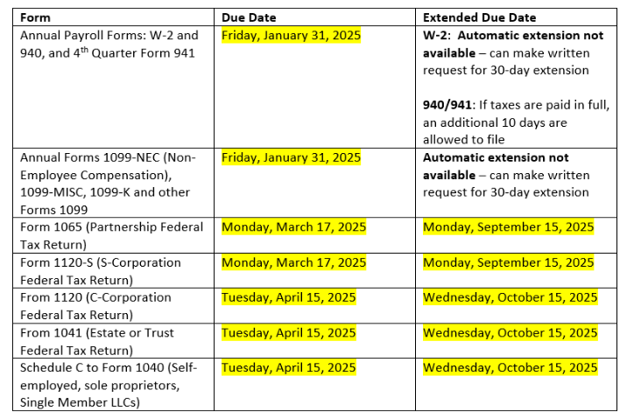
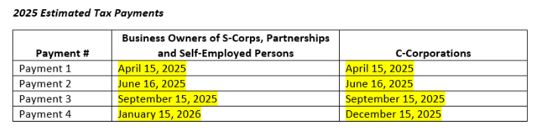
If you need assistance with determining estimated tax payment amounts, or you are unfamiliar with making quarterly estimated tax payments, please contact your tax preparer for more information.
Accounting and Bookkeeping
Complete and accurate financial statements are the starting point to prepare your W-2’s, 1099’s, and business tax return(s). If we have not yet discussed any of our assistance regarding the preparation your entity’s financial statements, please contact your tax preparer no later than January 8, 2025. We will discuss with you the specific terms of our work and the items that are needed to complete your 2024 accounting.
As a friendly reminder, you can upload documents for your business at any time via our secure access portal - SmartVault. If you have forgotten your password, or need the invitation to be re-sent, please contact Beth.
Form W-2 Reporting
Forms W-2 for 2024 are due to employees by Wednesday, January 31, 2025. W-2s are required for any employee to whom you made payments (including noncash payments) for services related to your trade or business during 2024, AND any person deemed to be a household employee. The due date for annual and fourth quarter payroll tax return reporting (Forms 940 and 941) is also January 31, 2025. State and local filing requirements generally follow the federal deadlines.
If you use a third-party payroll service, you should coordinate with them to ensure 2024 Forms W-2 (and all corresponding forms) are prepared and submitted in advance of the deadline. If you use QuickBooks Payroll, instructions to file are provided within your QuickBooks Payroll portal.
If we are currently engaged to prepare your payroll, we will reach out to you in early January to confirm we have all the required information. Please note that we will need all your payroll and 1099 information no later than January 15, 2025, to ensure we meet the IRS filing deadline.
If you need assistance with W-2 reporting, we can help! Please contact your payroll coordinator no later than January 8, 2025, and we will discuss your reporting requirements.
Do you have a household employee (nanny, housekeeper, gardener, etc.) and are not sure if they are an employee? The IRS provides a helpful publication, the Household Employer’s Tax Guide, to help you determine if you have a household employee. We can also help answer any questions you have and prepare the required payroll forms.
Certain fringe benefits, such as health insurance, auto allowance and others, may need to be reported on Form W-2. Please contact us if you have any questions regarding what compensation must be reported on Form W-2. Failure to issue Form W-2 or any other required payroll tax form could result in fines and penalties.
Form 1099 Reporting
All individuals and businesses that are deemed to be conducting a “trade or business” must issue Form 1099-NEC (nonemployee compensation) and/or other Forms 1099 to qualifying vendors, contractors, attorneys, and other persons. The filing due date for Forms 1099-NEC, 1099-MISC, 1099-K and other 1099’s is January 31, 2025.
Click these links to learn more about Forms 1099-MISC and 1099-NEC. We can also help answer any questions you have and prepare the required forms.
Forms 1099 are issued to nonemployee service providers including contractors and vendors who meet the following general requirements (detailed requirements are included in the above IRS instructions):
- Provide services to you (such as legal, engineering and other personal services), and
- Are not C- or S- corporations at year-end, and
- Receive more than $600 from you by cash or check during the year (Form 1099 reporting is NOT required for payments made by credit card, debit card or through third-party payment services such as PayPal. We recommend that businesses issue Forms 1099 for payments over $600 paid with cryptocurrencies).
Unincorporated residential rental property owners whose activities rise to the level of a “trade or business” must issue Forms 1099 if all the above requirements are met. Most individual owner’s residential properties do not rise to this level, and therefore do not need to issue Forms 1099. Please check with us if you are uncertain whether your rental business rises to the level of a trade or business.
It is a best practice to obtain a Form W-9 from all contractors and vendors annually, in advance of any payments. If you do not currently have a signed Form W-9 from all contractors and vendors with whom you paid more than $600 during 2024, we suggest you act immediately to obtain this form. Form W-9 includes relevant vendor information required to issue a Form 1099. You should obtain a properly filled-out and signed Form W-9 from all your contractors and vendors each year so that Form 1099 may easily be issued, if required.
If you are using QuickBooks Online, you may send requests for W-9 information through an email generated through QuickBooks. You may obtain blank Form W-9 here.
Failure to issue Forms 1099 may result in fines and penalties. In addition, it is also important to understand and correctly apply the rules for classifying a worker as an employee or as an independent contractor. The IRS provides a helpful analysis here.
We can help you with 1099 Reporting! Please contact Beth no later than January 8, 2024, and we will discuss your 1099 reporting requirements. Please note that we will need all your W-9 and vendor payment information no later than January 15, 2024, to ensure we meet the IRS filing deadline.

Please look for other mailings from Brenner Global Associates during January and February 2025:
- Welcome Letter to 2024 Individual Tax Return Preparation Season (January 2025)
- Access Instructions for Intuit Link and SmartVault (February 2025)
Brenner Global Associates, LLC – certified public accountants – is a firm of dedicated professionals focused on advisory, tax, and accounting for small and mid-sized businesses and individuals requiring international and multi-state expertise.

